Ryan Conley

Professor Volk Miller

WRIT 312

18 July 2023

Blog Entry and Site Analysis

Blog Entry:

Beginner’s Guide to *Kingsfall* in *Destiny 2*

Raids can be considered to be the pinnacle of cooperative gameplay in *Destiny 2,* the online multiplayer first person shooter released in 2017. As of 2023, *Destiny 2* boost 7 total raid, providing many challenging experiences to players willing to seek them out. One of the most popular raids is *Kingsfall,* a fan favorite raid that returns from the original *Destiny.* Be warned, raids have a steep difficulty compared to the standard gameplay within most of the game. It’s not unusual for raids to take more than an hour to complete, and each of them requires 6 players total, so you’ll need to get some experienced friends. Additionally, you’re going to need some serious weaponry to take on a raid, strong exotic and legendary weapons are recommended, and you’ll probably need a collection of exotics armors to actually beat the raid as well.

Encounter 1: Opening the Portal

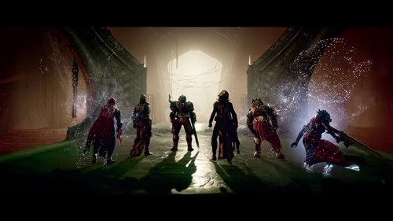

Once you load into the raid, you’ll find yourself facing a large portal with two branching paths to the left and right. To begin this encounter, you should divide your team into 2 sets of 3, one on the left and one on the right. Station one member from both of the teams in the middle section you start in. These two guys are going to shoot the balls of shadows to open the doors when requested. The other two members of each team are going to run down the hallways and retrieve glowing orbs. Make sure each team communicates when to grab the orbs, because they’re on a timer and if it expires, you’ll have to restart. Take turns grabbing the orbs and defending the runner. After completing 6 runs the portal should open.

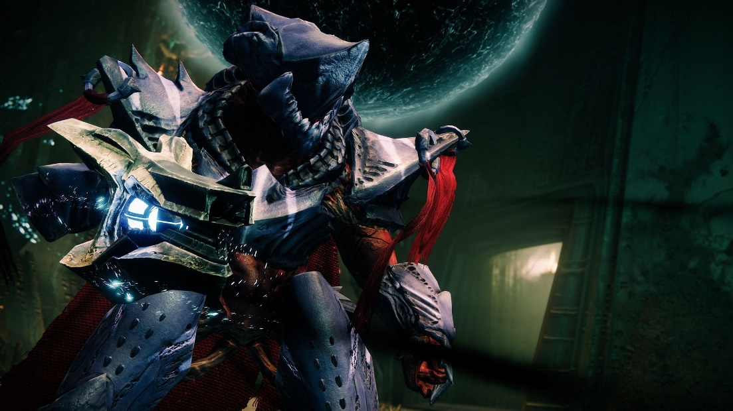 Encounter 2: The War Priest

After crossing the portal and doing a collection of jumping puzzles, you should find the War Priest, a giant purple monster wielding a huge axe. War Priest seems like a difficult encounter, but it’s really not. Divide your team into pairs, sending one to each of the three plates. Assign 1 person to read and another to defend the reader. The middle reader will hop on his/her plate and call out left of right, depending on which other plate is glowing. The 2nd reader will hop on, calling out the next glowing plate, until all 3 plates have been activated. At this point, the last reader will begin glowing, and you can shoot the War Priest. Just keep in mind while the team is dealing damage, the defenders should be hunting down Taken Knights, shadowy enemies that will extend the damage phase. After the damage phase ends, hid behind on of the three pillars, or you’ll get killed by the War Priest’s Oculus. Reduce the War Priest’s heath bar to an empty rectangle before the 4th time he calls on the Oculus, and you’ll defeat him.

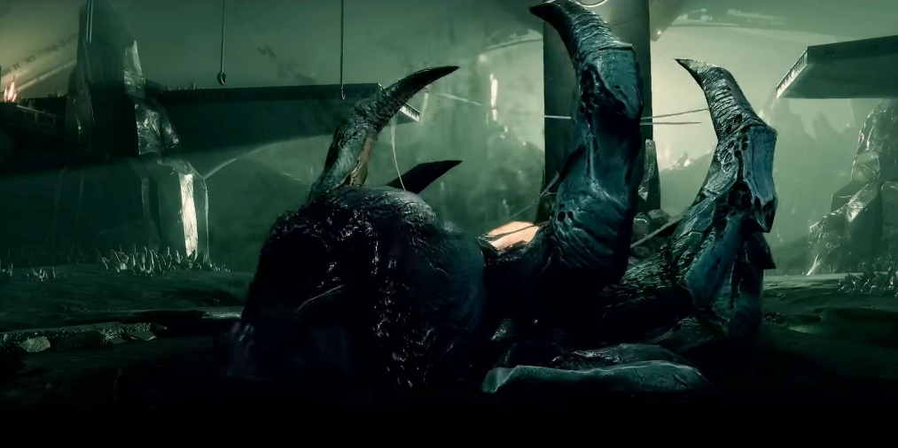 Encounter 3: Golgorath

Next, traverse the maze between the War Priest and Golgorath, the giant ogre with spider legs for hair. Once you arrive, you’ll see a ring-like arena with a bunch of water droplets on the ceiling. Send two people to be on “gaze team” their job will be shooting the back og Golgorath to keep his gaze. These two players should be extremely good at dodging projectiles, since Golgorath will launch poisonous bombs at them during the whole fight. Everyone else will gather in the center, and after the gaze team gets his attention start shooting down those water droplets. Sit in the puddle from the droplets to damage Golgorath, aiming at his stomach for maximum damage. While you’re in the puddle you might get a debuff that turns your screen green, if you get it run to Golgorath and away from your teammates, as you’ll deal massive damage to anyone that isn’t you. After a few runs, you should be able to whittle down the ogre, and pass onto the next encounter.

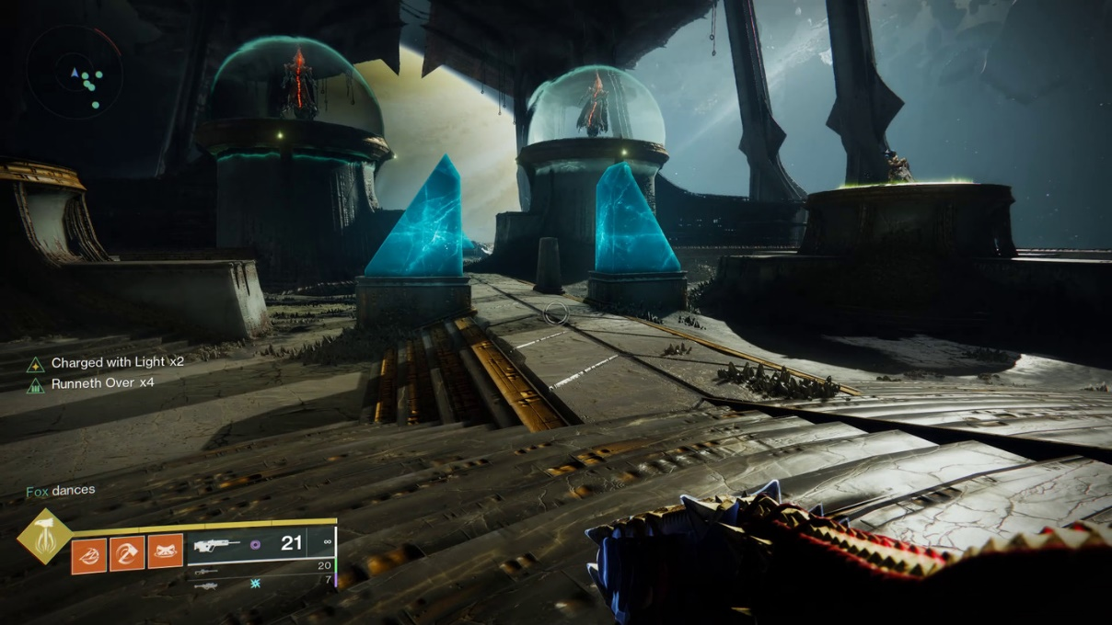 Encounter 4: The Daughters

Welcome to the final arena, and the second to last encounter. You’ll notice 4 plates, lovely called L1, L2, R1, and R2, the 1’s are closer to the door, and the 2’s are closer to the big open window. You’ll also notice two giant witches on a left and right pedestal between the plates. Someone will become taken, allowing them to see a hovering ball above the plates. Assign 4 people to plates, and 2 people to be floating, which means they will replace a plate person in the event they are taken.

Players will see plates grow, if your plate glows, hop on it and don’t hop off. This will form floating platforms from the starting plate to the floating orb, there should be two glowing plates every time. The taken player will jump up to the orb, take hold of it, and slam onto on of the witches. Everyone can gather around them and start shooting her, ideally you should be able to kill each witch in one phase. The catch is that every 3 minutes the witches will wipe the screen, killing everyone not next to the orb, so be careful as you go.

Encounter 5: The Taken King

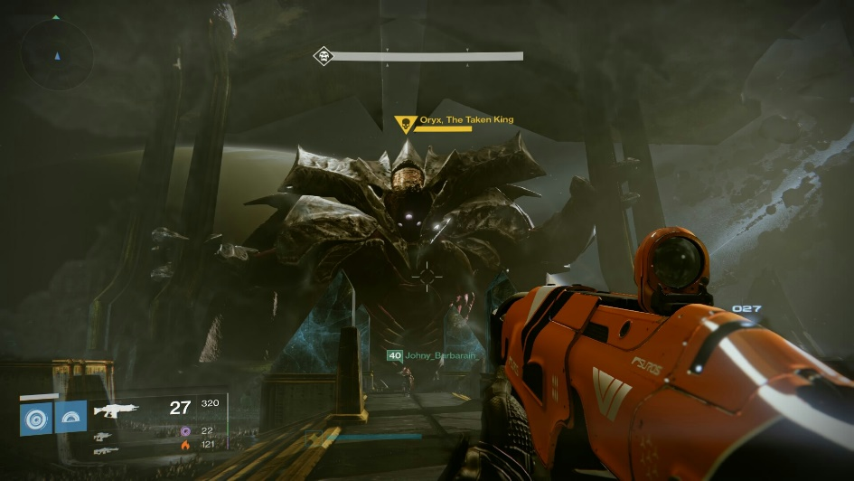

The final encounter is similar to the last one, with a few key changes. First, instead of two witches, there’s the giant undead alien called Oryx to replace them. Oryx will slam onto a plate to determine where it starts, and instead of grabbing an orb from the sky, the taken player will have to defeat a knight to activate the orb after jumping. The plate people will also have to kill light-eating ogres, which spawn during the encounter, just be careful not to step inside the sphere they leave behind. After the knight has been killed, all the plate people will activate the spheres, which will detonate, then everyone needs to get next to the player with the orb. These bombs will wipe the screen, like the witches in the last encounter, and which will also stun Oryx, allowing you to damage him.

After damage, Oryx will summon bombs or create a void and suck players in. If he makes bombs, just run away from everyone else until he stops, if he made the void, players will randomly warp inside and have to kill the Shade of Oryx, before being released. After this, simply rinse and repeat until you have killed the Taken King. Just remember that he has a final stand effect, where you’ll need to kill two additional light eating ogres and set off two more spheres while you’re dealing damage.

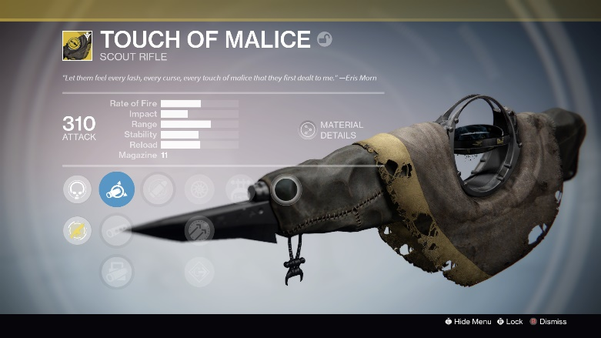

Congratulations, you’ve finished the raid, hopefully you got rewarded with the super rare weapon, Touch of Malice, but don’t worry if you didn’t, it’s not nearly as busted as in *Destiny.*

Site Analysis:

Kotaku is one of the most popular gaming blogs on the internet. It is dedicated mostly to video game reviews, but also features news and guides for video games. The main goal of this website is to inform its readers about current news in the video gaming world. The site also ventures into media associated with video games at times.

The blog site has many different writers, editors, and other staff working to keep the website up and running. It’s current editor in chief is Patricia Hernandez, and the website has an outstanding request for relevant stories and topic ideas to be submitted by the community.

Kotaku is written for an audience that has a very good understanding of video games and the culture surrounding them. The website regularly uses specific jargon and references other known topics and games that may make it difficult for outsiders to read.